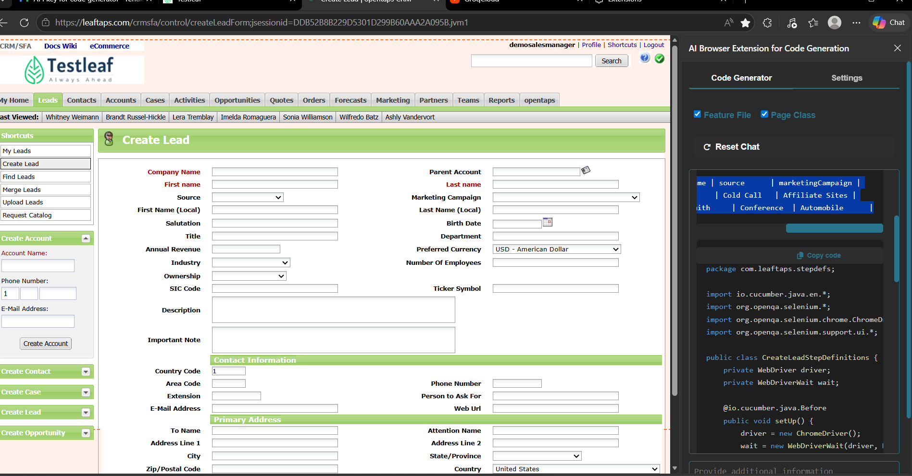

Feature: Create Lead

Scenario Outline: Create a new lead with valid details
Given I open the create lead page
When I enter "<companyName>" into the Company Name field
And I enter "<firstName>" into the First Name field
And I enter "<lastName>" into the Last Name field
And I select "<source>" from the Source dropdown
And I select "<marketingCampaign>" from the Marketing Campaign dropdown
And I click the Create Lead button
Then I should see the lead created successfully

Examples:
| companyName | firstName | lastName | source | marketingCampaign |
| Test Company | John | Doe | Cold Call | Affiliate Sites |
| ABC Corporation | Jane | Smith | Conference | Automobile |

Feature: Create Lead

Scenario Outline: Create a new lead with valid details
Given I open the create lead page
When I enter "<companyName>" into the Company Name field
And I enter "<firstName>" into the First Name field
And I enter "<lastName>" into the Last Name field
And I select "<source>" from the Source dropdown
And I select "<marketingCampaign>" from the Marketing Campaign dropdown
And I click the Create Lead button
Then I should see the lead created successfully

Examples:
| companyName | firstName | lastName | source | marketingCampaign |
| Test Company | John | Doe | Cold Call | Affiliate Sites |
| ABC Corporation | Jane | Smith | Conference | Automobile |

package com.leaftaps.stepdefs;

import io.cucumber.java.en.*;
import org.openqa.selenium.*;
import org.openqa.selenium.chrome.ChromeDriver;
import org.openqa.selenium.support.ui.*;

public class CreateLeadStepDefinitions {
private WebDriver driver;
private WebDriverWait wait;

@io.cucumber.java.Before
public void setUp() {
driver = new ChromeDriver();
wait = new WebDriverWait(driver, Duration.ofSeconds(10));
driver.manage().window().maximize();
}

@io.cucumber.java.After
public void tearDown() {
if (driver != null) driver.quit();
}

@Given("I open the create lead page")
public void openCreateLeadPage() {
driver.get("https://leaftaps.com/crmsfa/control/createLeadForm;jsessionid=DDB52B8B229D5301D299B60AAA2A095B.jvm1");
}

@When("I enter {string} into the Company Name field")
public void enterCompanyName(String companyName) {
WebElement el = wait.until(ExpectedConditions.elementToBeClickable(By.id("createLeadForm_companyName")));
el.sendKeys(companyName);
}

@When("I enter {string} into the First Name field")
public void enterFirstName(String firstName) {
WebElement el = wait.until(ExpectedConditions.elementToBeClickable(By.id("createLeadForm_firstName")));
el.sendKeys(firstName);
}

@When("I enter {string} into the Last Name field")
public void enterLastName(String lastName) {
WebElement el = wait.until(ExpectedConditions.elementToBeClickable(By.id("createLeadForm_lastName")));
el.sendKeys(lastName);
}

@When("I select {string} from the Source dropdown")
public void selectSource(String source) {
WebElement el = wait.until(ExpectedConditions.elementToBeClickable(By.id("createLeadForm_dataSourceId")));
Select select = new Select(el);
select.selectByVisibleText(source);
}

@When("I select {string} from the Marketing Campaign dropdown")
public void selectMarketingCampaign(String marketingCampaign) {
WebElement el = wait.until(ExpectedConditions.elementToBeClickable(By.id("createLeadForm_marketingCampaignId")));
Select select = new Select(el);
select.selectByVisibleText(marketingCampaign);
}

@When("I click the Create Lead button")
public void clickCreateLeadButton() {
driver.findElement(By.name("submitButton")).click();
}

@Then("I should see the lead created successfully")
public void verifyLeadCreated() {
WebElement success = wait.until(ExpectedConditions.visibilityOfElementLocated(By.className("x-msg-box")));
assert success.isDisplayed();
}
}

Week 3 Day 1 Homework - Playwright typescript implementation
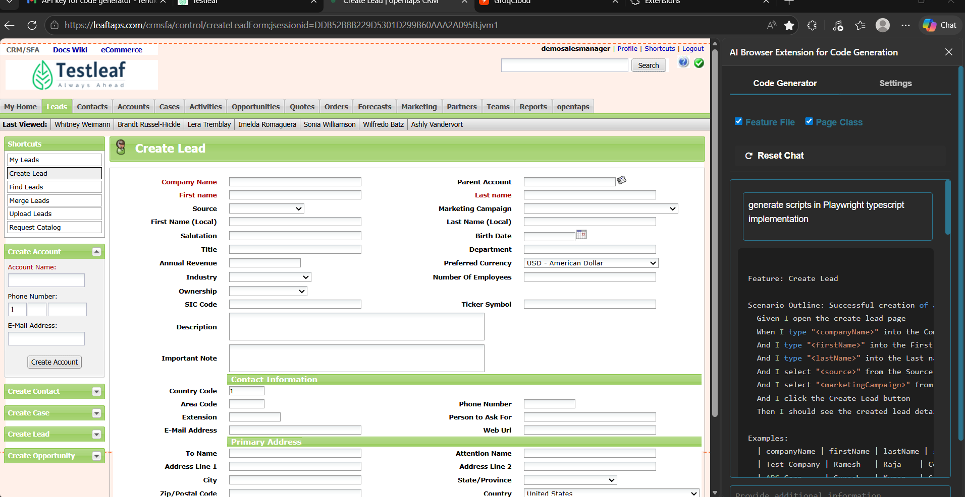

Feature: Create Lead

Scenario Outline: Successful creation of a lead
Given I open the create lead page
When I type "<companyName>" into the Company Name field
And I type "<firstName>" into the First name field
And I type "<lastName>" into the Last name field
And I select "<source>" from the Source dropdown
And I select "<marketingCampaign>" from the Marketing Campaign dropdown
And I click the Create Lead button
Then I should see the created lead details

Examples:
| companyName | firstName | lastName | source | marketingCampaign |
| Test Company | Ramesh | Raja | Cold Call | Affiliate Sites |
| ABC Corp | Suresh | Kumar | Conference | Automobile |

package com.leaftaps.stepdefs;

import io.cucumber.java.en.*;
import org.openqa.selenium.By;
import org.openqa.selenium.WebDriver;
import org.openqa.selenium.WebElement;
import org.openqa.selenium.chrome.ChromeDriver;
import org.openqa.selenium.support.ui.ExpectedConditions;
import org.openqa.selenium.support.ui.WebDriverWait;

public class CreateLeadStepDefinitions {
private WebDriver driver;
private WebDriverWait wait;

@io.cucumber.java.Before
public void setUp() {
driver = new ChromeDriver();
wait = new WebDriverWait(driver, java.time.Duration.ofSeconds(10));
driver.manage().window().maximize();
}

@io.cucumber.java.After
public void tearDown() {
if (driver != null) driver.quit();
}

@Given("I open the create lead page")
public void openCreateLeadPage() {
driver.get("https://leaftaps.com/crmsfa/control/createLeadForm;jsessionid=DDB52B8B229D5301D299B60AAA2A095B.jvm1");
}

@When("I type {string} into the Company Name field")
public void enterCompanyName(String companyName) {
WebElement el = wait.until(ExpectedConditions.elementToBeClickable(By.id("createLeadForm_companyName")));
el.sendKeys(companyName);
}

@When("I type {string} into the First name field")
public void enterFirstName(String firstName) {
WebElement el = wait.until(ExpectedConditions.elementToBeClickable(By.id("createLeadForm_firstName")));
el.sendKeys(firstName);
}

@When("I type {string} into the Last name field")
public void enterLastName(String lastName) {
WebElement el = wait.until(ExpectedConditions.elementToBeClickable(By.id("createLeadForm_lastName")));
el.sendKeys(lastName);
}

@When("I select {string} from the Source dropdown")
public void selectSource(String source) {
WebElement el = wait.until(ExpectedConditions.elementToBeClickable(By.id("createLeadForm_dataSourceId")));
el.click();
wait.until(ExpectedConditions.elementToBeClickable(By.xpath("//option[text()='" + source + "']"))).click();
}

@When("I select {string} from the Marketing Campaign dropdown")
public void selectMarketingCampaign(String marketingCampaign) {
WebElement el = wait.until(ExpectedConditions.elementToBeClickable(By.id("createLeadForm_marketingCampaignId")));
el.click();
wait.until(ExpectedConditions.elementToBeClickable(By.xpath("//option[text()='" + marketingCampaign + "']"))).click();
}

@When("I click the Create Lead button")
public void clickCreateLead() {
driver.findElement(By.name("submitButton")).click();
}

@Then("I should see the created lead details")
public void verifyLeadCreation() {
// Add verification logic here
System.out.println("Lead created successfully");
}
}

import { test, expect } from '@playwright/test';

test('Create Lead', async ({ page }) => {
await page.goto('https://leaftaps.com/crmsfa/control/createLeadForm;jsessionid=DDB52B8B229D5301D299B60AAA2A095B.jvm1');

await page.fill('#createLeadForm_companyName', 'Test Company');
await page.fill('#createLeadForm_firstName', 'Ramesh');
await page.fill('#createLeadForm_lastName', 'Raja');

await page.selectOption('#createLeadForm_dataSourceId', 'LEAD_COLDCALL');
await page.selectOption('#createLeadForm_marketingCampaignId', '9002');

await page.click('input[name="submitButton"]');

await expect(page).toContainText('Lead created successfully');
});
Copy

